Strength training and measurement Symposium Göteborg – Aarhus – Oslo
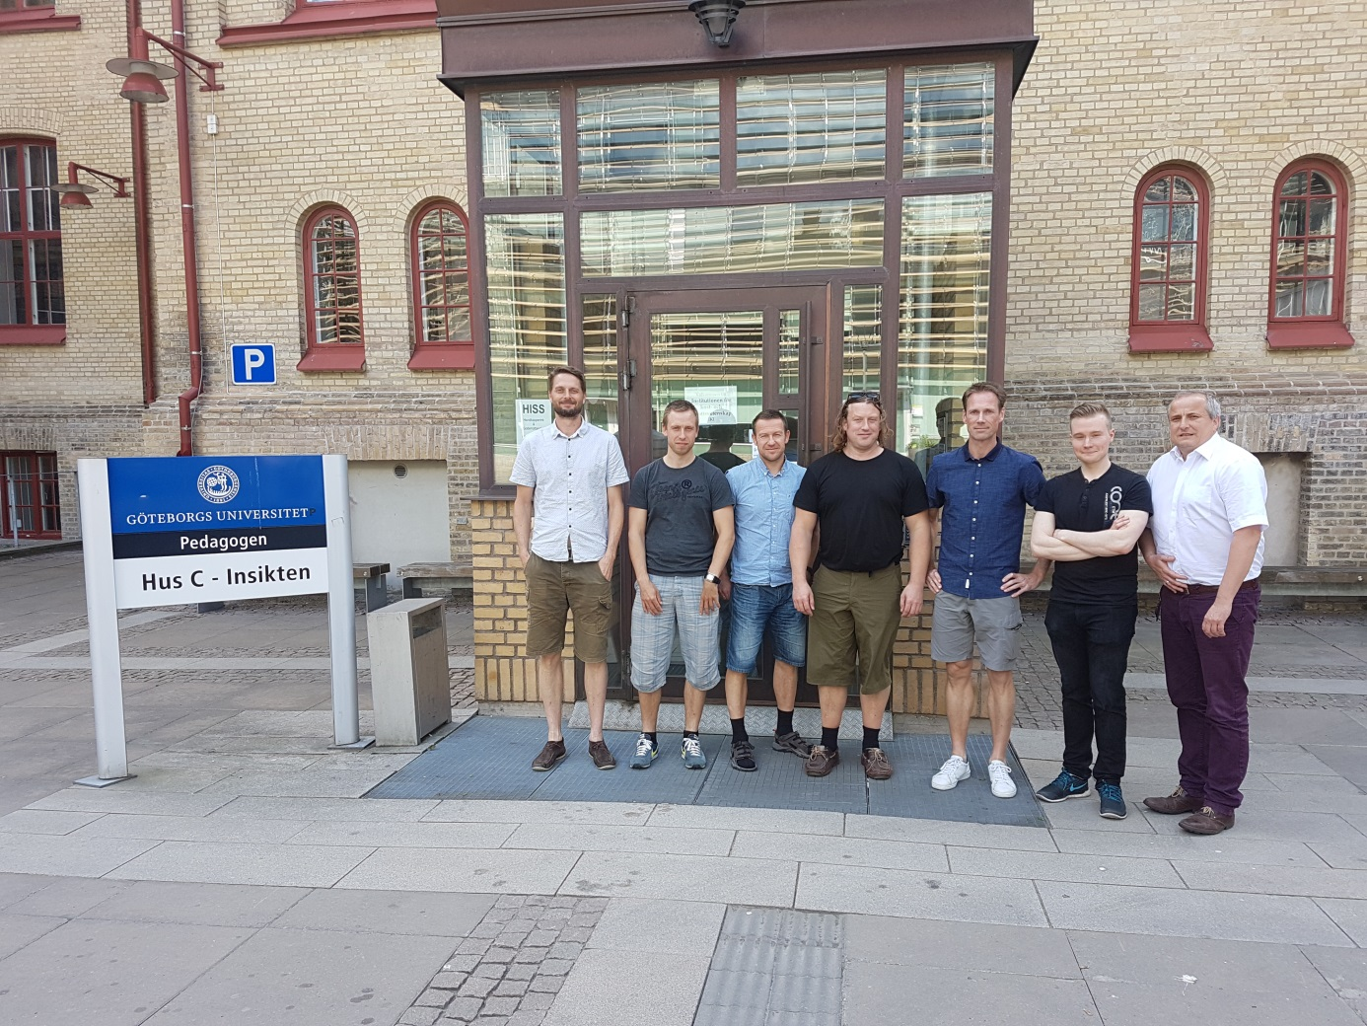
Organizer: University of Gothenburg, Mathias Wernbom
Location: Department of Food and Nutrition and Sport Science (Institutionen för kost- och idrottsvetenskap, IKI), at Pedagogen Hus C, Läroverksgatan 5, room CE38.
Date: Tuesday 31st of May 2016.

General Goals of collaboration: Strengthen common teaching/lecturing & research at the three universities (Aarhus University, Norwegian School of Sport Sciences, University of Gothenburg).

Specific goals and suggested contents of the Symposium:
- Mark the start of a collaboration between all three universities with the aim to forward research related to strength training and testing
- Strengthen already ongoing research collaborations and exchanges with regard to training topics/issues
- 3 keynote presentations (one from each university)
- 2 additional presentations from each university. This could be from junior researchers/master students (e.g. presentation of ongoing theses, upcoming study or planning of study etc), which are then followed by feedback (strengths and weaknesses of the study or research plan, etc).
Alternatively, 1 or 2 of these additional presentations could be from other researcher(s) from the same university
- Critical discussion and reflection of training related issues to improve overall quality and impact of research
- Exchange training and technical expertise of the three universities in order to make use of each other’s strengths in our research
- Establish contacts between young students in conjunction with their scientific presentations
- Networking between scientific staff of the three universities and between young and experienced researchers

Suggested schedule:
8.30 – 8.45 Welcome and introduction, Presentation of IKI and KHP . Professor Stefan Grau, Co-Head of KHP.
8.45 – 9.30 Keynote 1: Professor Truls Raastad, NSSS/NIH, Oslo. Suggested topic: Research on Strength training and Recovery from “The Muscle Group” at the Norwegian School of Sport Sciences.
9.30 – 9.45 Presentation 1 Oslo (student or researcher)
9.45 – 10.00 Presentation 2 Oslo (student or researcher)
10.00 – 10.30 Discussion of Oslo research
10.30 – 11.00 Coffee
11.00 – 11.45 Keynote 2: Associate professor Kristian Vissing, Aarhus University. Research on Strength Training and Muscle Hypertrophy at the Aarhus University.
11.45 – 12.30 Keynote 3: Associate professor Kristian Overgaard, Aarhus University. Research on Muscle Damage and Fatigue at the Aarhus University.
12.30 – 13.00 Discussion of Aarhus research
13.00 – 14.00 Lunch
14.00 – 14.45 Keynote 4: post doc Mathias Wernbom, University of Gothenburg. Studies on muscle hypertrophy mechanisms with ischemic strength training (blood flow restricted resistance exercise).
14.45 – 15.00 Coffee
15.00 – 15.15 Presentation 2 Göteborg (Mikael Gustafsson, master student)
15.15 – 15.45 Discussion of Göteborg research
15.45 – 16.00 Closure (Stefan Grau)
16.00- Possibility to get a guided tour through labs (movement, strength, physiology) at the KHP after the meeting. Possibility to continue informal discussions.

Keynotes should be approximately 35min plus 10min of discussion.
The additional 2 presentations will be discussed together after the second presentation.
Alternatively, there is the possibility to have 2 Keynotes + 1 student/researcher presentation, or 2 Keynotes. The lengths of these are adjusted accordingly.
Presentations have to be in English.
The three universities can invite additional staff or students from their universities (not open to public).
Hope to see you in Gothenburg at the 31st of May!

