Ideas and Challenges Marketplace
On the ‘Ideas and Challenges’ marketplace, WorldLabs members (both industrial and academic) can post ideas and industry challenges which can form the basis of an ODIN project application. By posting ideas or challenges, ODIN members indicate their interest in developing an open project and can source further input and partners.

NOTES and TIPS:
- The deadline for posting ideas for the Grant Type 1 Call is 29 April 2026.
- Teams do not have to be fully formed before posting the idea. The marketplace can (and should) be used as a tool to find additional partners/resources. You can browse and contact all current ODIN members here or through individual idea/challenge or resource postings.
- Ideas do not have to be fully formed before posting. As new partners join, it is expected that the project will develop further and may change significantly.
- Main applicants must consult their local business developer either shortly before or after posting the WorldLabs idea in order to discuss precompetitiveness and openness.
- If you are seeking partners that are not on WorldLabs, contact the secretariat odin@au.dk after posting and we can provide additional matchmaking services.
- Abstract applications that are not clearly linked to an idea/challenge/resource posted in the Marketplace will be administratively rejected without review.

⚠️Any information, documents or images that you upload will be visible to WorldLabs members, so please do not upload any private or confidential information that you do not wish to share. You may edit your post at any time after publishing.

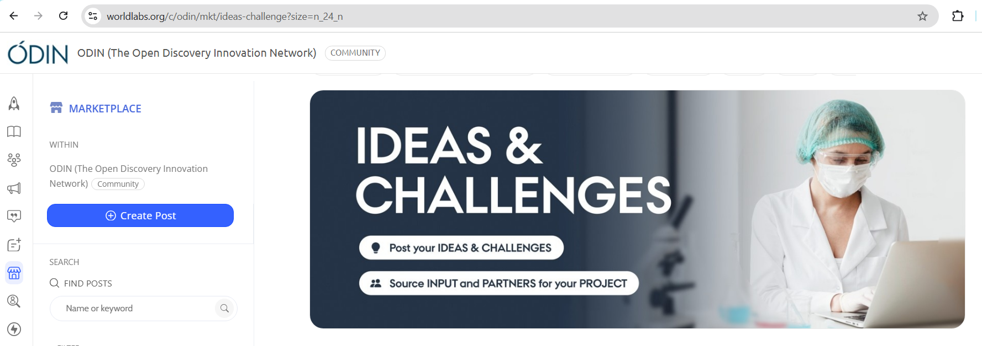

The following pages contain a template you can use before posting online.
Title
Summarize your idea or challenge, aiming for clarity and impact. Only the first ca. 50 characters will show on the front page summary.
Add your answer here…

Description of Idea or Challenge
Briefly describe the unmet need your project aims to address and (if relevant) your suggested approach to solving it. Highlight anticipated outcomes, along with the project's capacity for fostering innovation and its potential applicability to other diseases and research fields. Only the first ca. 120 characters will be shown on the front page summary.
Add your answer here…

Cover Image
Upload an image to visually represent the idea/challenge. This image will show up only on the front page of the marketplace with your post summary. You may add additional images within the post in a later question. (recommended ratio 15:9, size: 300x180 pixels)
JPEG, JPG or PNG file up to 10MB . Upload to WorldLabs

Grant Type
For which grant type would you like to apply?
- Grant type 1 for new projects (in 2026: up to three years and DKK 6,5 Million)
- Grant type 2A, top-up grant available only to previously funded ODIN projects (in 2026: up to 1 year and DKK 1,5 Million)

Workplace of the main contact
Select the type of organisation to which you (as the proposer) currently belong.
- Aalborg University
- Aarhus University
- Technical University of Denmark
- University of Copenhagen
- University of Southern Denmark
- Other University
- Hospital
- Industry
- Other organisation (not a hospital, company or university)

Main Contact Email
Email address for the main contact (although recommended, this is optional because the poster can also be contacted directly via our platform through the ‘Message’ button)
Add your answer here…

Team Information
Include professional details for yourself and your current team members (if you have any). This will give others an idea of your current expected consortium. We suggest that you include the following for each known team member:
- Organisation and Department
- Individual Name(s) and Professional Title(s)
Please clearly label the main contact.
Add your answer here…

Resources Available
Describe the current competencies and resources available (the expertise, technologies, and methods currently available to the project).
Add your answer here…

This idea is proposed for the following call year(s)
Select which call year your project idea/challenge is relevant for.
*Most posters should choose 2026. If you are editing an idea that was proposed for a previous call year, please do not delete that year from the list - rather just add 2026.

⚠️ If you are editing a post from a previous year, note that some questions have been changed or added. Read through your responses and update where appropriate
- 2024
- 2025
- 2026

Idea/Challenge Area
Please select which area(s) your idea or challenge falls within the ODIN scientific scope.
- CMD - cardiometabolic diseases
- CVD - cardiovascular diseases
- Infectious diseases
- Regenerative medicine
- Disease-agnostic platform technologies or research tools/methods for broader healthcare applications
- CNS – Diseases of the central nervous system

Partners needed
Indicate which type of partners you are seeking to add to the project. The strongest teams traditionally have multiple partners sourced through matchmaking. Choose one or more options in the below drop-down menu.
⚠️ Main applicants must be associate or full professor from one of the following: Aalborg University, Aarhus University, Technical University of Denmark, University of Copenhagen or University of Southern Denmark.
- Main applicant (associate or full professor)
- Co-applicant(s) (university, hospital or other non-profit)
- Company partner(s)

Resources Needed
Briefly describe which competencies or resources you are looking for, e.g. material input or contributions, intellectual input, access to facilities/equipment etc.
Add your answer here…

Precompetitiveness & Openness
It is important to carefully define the boundaries of the ODIN project and consider all potential outcomes that will be made available to the public. Please describe:
a) the nature of the potential project output(s)
b) you and your team's interest in the output (how might you/your team use it for further research or innovation?)
c) how the outputs could be of interest and useful to the wider academic and industrial community beyond your own team (how might others use it for further research or innovation?)
NOTES:
- It is a central principle in the ODIN model that research projects must be precompetitive, meaning that results created during the project are not eligible for patent protection (IPR), because they are e.g. too early or too fundamental in nature.
- Since all project data and results created during an ODIN project must be openly shared, they become part of the public domain, making them broadly available and applicable for the benefit of others.
- Main applicants must contact their local business developer to discuss precompetitiveness and openness before submitting an abstract. If you are not from a main applicant institution, contact ODIN if you are unsure whether your idea is precompetitive and can be shared openly. odin@au.dk
Add your answer here…

Relevant Link (optional)
Add a link, such as a website, that is relevant to your idea or challenge.
Add URL here…

Additional Images (optional)
If you have any additional images or graphics to share, you can upload them here. These will appear within the post. You may also re-upload your cover image if desired, otherwise it won't show within the post.

Relevant Documents (optional)
You can optionally add relevant information sheets or presentations that better explain your idea or challenge. Upload to WorldLabs

Video (optional)
If you have any video materials supporting your idea/challenge, you can upload them to Worldlabs. Eg: Project pitches etc.

Sectors
Select the sectors that most closely align with the content of your post. While this information will not appear in the actual post, it will enhance post discoverability.
(Drop down list of options)

Keywords
You can add keywords here

