IDEAS AND CHALLENGES MARKETPLACE
On the ‘Ideas and Challenges’ marketplace, WorldLabs members (both industrial and academic) can post ideas and challenges which can form the basis of an ODIN project application. By posting, ODIN members indicate their interest in developing an open project and can source further input and partners.

NOTES and TIPS:
- The deadline for posting ideas and challenges for the Grant Type 2A Call is 13 September 2026. However, if facilitated matchmaking is needed, the ideas or challenges must be posted before 23 August 2026. This includes if you are seeking partners that are not on WorldLabs. Please contact the ODIN Secretariat at odin@au.dk after posting.
- Teams do not have to be fully formed before posting the idea or challenge. The marketplace can (and should) be used as a tool to find additional partners/resources. You can browse and contact all current ODIN members here or through individual idea/challenge or resource postings.
- Ideas do not have to be fully formed before posting. As new partners join, it is expected that the project will develop further and may change significantly.
- Main applicants must consult their local development advisor in order to discuss precompetitiveness and openness before submitting an application.
- Applications that are not clearly linked to an idea/challenge/resource posted in the Marketplace will be administratively rejected without review.
⚠️Any information, documents or images that you upload will be visible to WorldLabs members, so please do not upload any private or confidential information that you do not wish to share. You may edit your post at any time before the deadline.

⚠️ If you are editing a post from a previous year, note that some questions have been changed or added. Read through your responses and update where appropriate

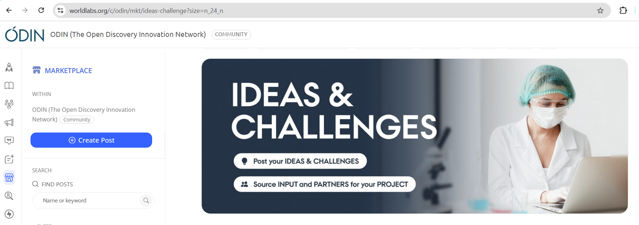

The following pages contain a template to prepare before posting online, if desired.

Title
Summarize your idea or challenge, aiming for clarity and impact. Only the first ca. 50 characters will show on the preview page once published.
Add your answer here…
Description of Idea or Challenge
Briefly describe the unmet need your project aims to address and (if relevant) your suggested approach to solving it. Highlight the potential future benefits to drug discovery and/or diagnostics development. Only the first ca. 120 characters will be shown on the preview page once published.
Add your answer here…
Cover Image (optional)
Upload a cover image to visually represent the idea/challenge on the preview page. You may add additional images within the post in a later question. (recommended ratio 15:9, size: 300x180 pixels)
JPEG, JPG or PNG file up to 10MB . Upload to WorldLabs
Workplace of the main contact
Select the type of organisation to which you (as the proposer) currently belong.
- Aalborg University
- Aarhus University
- Technical University of Denmark
- University of Copenhagen
- University of Southern Denmark
- Other University
- Hospital
- Industry
- Other organisation (not a hospital, company or university)
Main Contact Email
Email address for the main contact (the poster can also be contacted directly via our platform through the ‘Message’ button). The poster and main contact may not always be the same person, although both should be available to discuss the project.
Write email address only…
Resources Available
Briefly describe the current team, competencies and resources available to the project.
Add your answer here…
Resources Needed
Briefly describe which competencies or resources you are looking for, e.g. material input or contributions, intellectual input, access to facilities/equipment etc.
Add your answer here…
Precompetitiveness & Openness
It is important to carefully define the boundaries of the ODIN project and consider all potential outcomes that will be made available to the public. Please describe:
- the nature of the potential project output(s) (what data will be created, and how will it be shared openly?)
- you and your team's interest in the output (how might you/your team use it for further research or innovation?)
- how the outputs could be of interest and useful to the wider academic and industrial community beyond your own team (how might others use it?)
NOTES:
- It is a central principle in the ODIN model that research projects must be precompetitive, meaning that results created during the project are not eligible for patent protection (IPR), because they are e.g. too early or too fundamental in nature.
- Since all project data and results created during an ODIN project must be openly shared, they become part of the public domain, making them broadly available and applicable for the benefit of others.
- Contact ODIN if you are unsure whether your idea is precompetitive and results can be shared openly. odin@au.dk
Add your answer here…
Grant Type
For which grant type would you like to apply?
- Grant type 1 for new projects (in 2026: up to three years and DKK 6.5 Million)
- Grant type 2A, top-up grant available only to previously funded ODIN projects (in 2026: up to 1 year and DKK 1.5 Million)
This idea is proposed for the following call year(s)
Select which call year your project idea/challenge is relevant for. In 2026, choose ‘2026’
* If you are editing an idea that was proposed for a previous call year, please do not delete that year from the list - rather just add 2026.
Choose year(s) from options…
Idea/Challenge Area
Select which area(s) your idea or challenge falls within the ODIN scientific scope.
⚠️Please note that CNS – Diseases of the central nervous system is only relevant for Grant type 1.
- CMD - cardiometabolic diseases
- CVD - cardiovascular diseases
- Infectious diseases
- Regenerative medicine
- Disease-agnostic platform technologies or research tools/methods for broader healthcare applications
- CNS – Diseases of the central nervous system
Partners needed
Indicate which category of partner(s) you are seeking to add to the project. The strongest teams traditionally have multiple partners sourced through matchmaking. Choose one or more options.
We are seeking the following partner(s):
- Main applicant (associate or full professor from Aalborg Uni, Aarhus Uni, Technical Uni of Denmark, Uni of Copenhagen or Uni of Southern Denmark)
- Co-applicant(s) (university, hospital or other non-profit)
- Company partner(s)
Relevant Link (optional)
Add a link, such as a website, that is relevant to your idea or challenge.
Additional Images (optional)
If you have any additional images or graphics to share, you can upload them here. These will appear within the post. You can also re-upload your cover image, otherwise it won't show within the post.
Relevant Documents (optional)
You can optionally upload relevant info or presentations that explain your idea or challenge.
Video (optional)
Upload any video materials supporting your idea/challenge. Eg: Project pitches etc.
Sectors
Select the sectors that most closely align with the content of your post. While this information will not appear in the actual post, it will enhance post discoverability.
Drop down list of options, common choices are ‘Healthcare’ and/or ‘Science, Biotech & Pharma’
Keywords
Must add at least one keyword (free text)

