ODIN Application Template

2026 Grant Type 2A

Please submit your application via the online form here: https://www.worldlabs.org/opportunity/2026-grant-2-a-application

This template is available as a tool for your team to collaborate and prepare your application before completing the online submission. It includes additional descriptions, notes and examples to guide you. If there are any discrepancies between this template and the online form, the online form takes precedence.

Be sure to consult the current ODIN Grant 2A Application Guidelines to verify your eligibility, permissions, and understanding of the selection criteria. We also recommend using the final checklist (at the bottom of this form) to ensure your application is complete. You can find all templates and relevant documents for 2026 ODIN Grant 2A here: https://www.worldlabs.org/opportunity/2026-grant-2-a-application/resources

Deadline for submission via WorldLabs: 24 September, 15:00 CEST.

IMPORTANT NOTES:
Before submission of this application via WorldLabs, applicants must:
- Post the idea or challenge publicly on the WorldLabs Ideas & Challenges Marketplace: https://www.worldlabs.org/c/odin/mkt/ideas-challenge (final deadline 13 September).*
- Consult a local development advisor from the main applicant organisation.*
- Sections marked in red are used internally & not shared with reviewers.

*Failure to do so will result in administrative rejection of the application.

Additional Tips:
- This document does not automatically count characters. Leave ~5% margin, as online forms may count characters slightly differently.
- Formatting (e.g., bullets, italics, bold, line breaks) may, with a few exceptions, be used in the online application and this is encouraged for ease of reading by the reviewers.
- Cite key references [#] where relevant.

1. GENERAL INFORMATION & ELIGIBILITY CHECKS – This section uses plain text

1A. Name of Main Applicant
Add your answer here…

1B. Grant Type 2A (GT2A) Project Acronym (Character limit: 15)

1C. GT2A Project Title (Character limit: 150)

1D. Acronym of related ODIN project
Write the acronym of the original related ODIN Grant Type 1 or Pilot project.

1E. Project length in months (Character limit: 2)
Projects can be up to 12 months in length. Projects granted in 2026 must start between
01/03/2027 – 01/07/2027 as indicated in the Gantt chart.
Number of months

1F. Budget (Character limit: 10)

1G. Main applicant’s university
Choose one of the 5 Danish partners from a drop-down menu
  - 1H. Main applicant’s email address
  - 1I. Main applicant’s phone number
  - 1J. Main applicant’s eligibility
- The main applicant is a permanent (time-unlimited) or tenure-track employee at a level equivalent to associate professor or full professor.
- Yes
- No

1K. Main applicant’s relation to original project
The main applicant is:
- Previous main applicant on related Grant Type 1 or Pilot project
- Previous co-applicant on related Grant Type 1 or Pilot project
  - 1L. WorldLabs post
Provide the link to the ODIN Worldlabs Marketplace post that describes the idea or challenge that is associated with the GT2A project. To do this, enter the Marketplace, click on the relevant post, and copy the link associated with the open post. The string of letters and numbers is your unique post identifier.
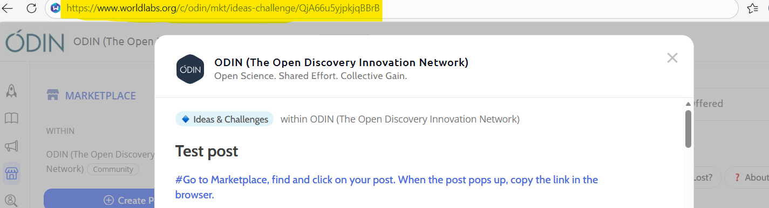
Example: https://www.worldlabs.org/c/odin/mkt/ideas-challenge/QjA66u5yjpkjqBBrB

Add your answer here…
  - 1M. Local development advisor contact
Before applying, the project must be discussed with a local development advisor from the main applicant’s university. This person must assess the project idea and indicate that:
- The proposed project appears to be precompetitive.
- Any new knowledge and outputs created within the project timeline can be shared openly with the public.
- The project does not appear to violate pre-existing intellectual property rights.
List the name and organisation of the local development advisor to whom you spoke.
  - 1N. ODIN’s privacy policy
We process your personal data in connection with the evaluation of this application through ODIN’s privacy policy. https://projects.au.dk/fileadmin/projects/odin2/Docs/ODIN_Privacy_Policy.pdf
Have the project participants read ODIN’s Privacy Policy?
- Yes
- No

1O. Open Sharing Compliance
The applicants confirm that all new outputs developed or created during this project (including knowledge, data, protocols, software, reagents, methods, tools, and negative results) can be openly shared without usage restriction or IP protection, and no later than 6 months after the project’s end.
- Yes
- No
  - 1P. Contact person during administrative review
Please provide the name, email and phone number of an alternative person who can be contacted during the administrative review process (24-29 September) in case any questions arise, if the main applicant is unavailable. This person should have access to all documents, the WorldLabs application, and permission from the main applicant to edit the application if necessary.
Name, email, phone

2. SCOPE

2A. Primary Scientific Scope Area (select one)
Select the primary area your GT2A project falls within the ODIN scientific scope. GT2A applications must fall within the scientific scope of the 2026 GT2A call. Please note that CNS is not a directly eligible scope area for top-up grants in 2026.
- Cardiometabolic diseases
- Cardiovascular diseases
- Infectious diseases
- Regenerative medicine
- Disease-agnostic platform technology or research tool/method for broader healthcare applications

2B. Secondary Scope Area(s) (optional)
Select any secondary area(s) your GT2A project falls within the ODIN scientific scope.
Select all that apply, but do not include the primary scope.
If your project only falls under one scope area, skip this question.
If the primary scope is “disease-agnostic platform technology or research tool/method for broader healthcare applications,” the project must also be relevant to one or more of the other eligible GT2A scope areas.
Same options as above
NOTE: Formatting (e.g., bullets, italics, bold, linebreaks) may be used in the remaining sections, and this is encouraged for ease of reading.

3. TEAM
3A. All universities/hospitals/other non-profit applicants
List the organisation of each applicant (universities, hospitals, and other non-profit organisations) participating in your GT2A project.
- Label each applicant organisation as guided in the examples. These should align with each budget tab label.
- Do not include names of people
- Do not include for-profit company partners
- If an applicant has dual university/hospital employment and requires separate budgets for each organisation, the organisations can be listed as separate applicants.

Example Answer (illustrated in figure under question 3C):
Main Applicant Organisation: Technical University of Denmark, Dept of Chemistry, DK
Applicant 2 Organisation: Aalborg University Hospital, Dept of Radiology, DK
Main Applicant Organisation: Organisation name, department, country
Applicant 2 Organisation: Organisation name, department, country
Applicant X Organisation: Organisation name, department, country
3B. For-profit company partner(s)
List the for-profit company partner(s) participating with in-kind support. Only include the company name, department (if relevant), and country where the company research will be located.
- Label each company as guided in the examples.
- Do not include names of people

Example Answer (illustrated in figure under question 3C):
Company 1: Novo Nordisk, Cell Therapy R&D, DK
Company 2: DeepCure, USA
Company 1: Company name, department, country
Company 2: Company name, department, country
3C. All Project Participants
Provide details of each individual project participant, including name, academic and/or professional title, organisation, country, email address, and phone number. This includes:
- A1: The eligible person leading the ‘Main Applicant Organisation’ group and who is responsible for the entire ODIN project
- Applicant A2 to Ax: The person who is leader of each co-applicant group
- A1-R1 to Ax-Ry and C1-R1 to Cx-Ry: Researchers and other staff working on the project under the applicant groups and company partners
- These labels should align with the questions 3A-B, the Gantt and the Budget

Example Answer (illustrated in figure below):
Main applicant (A1): John Smith, PhD, Head of Smith research group, Technical University of Denmark, Dept. of Chemistry, Denmark, john.smith@dtu.dk, +4512345678
A2: Jan Doe, assistant professor, Aalborg University Department of Clinical Medicine & Aalborg University Hospital, Dept of Radiology, DK, jd@aau.dk , +4567899876
C1: Joe Shmoe, senior researcher, Novo Nordisk, Cell Therapy R&D, DK, josh@novo.com, +4512341234
A1-R1: Freja Bensen, PhD, postdoc, Aalborg University Hospital, Dept. of Radiology and Dept. of Clinical Medicine, DK, fejb@aau.dk +4599999999
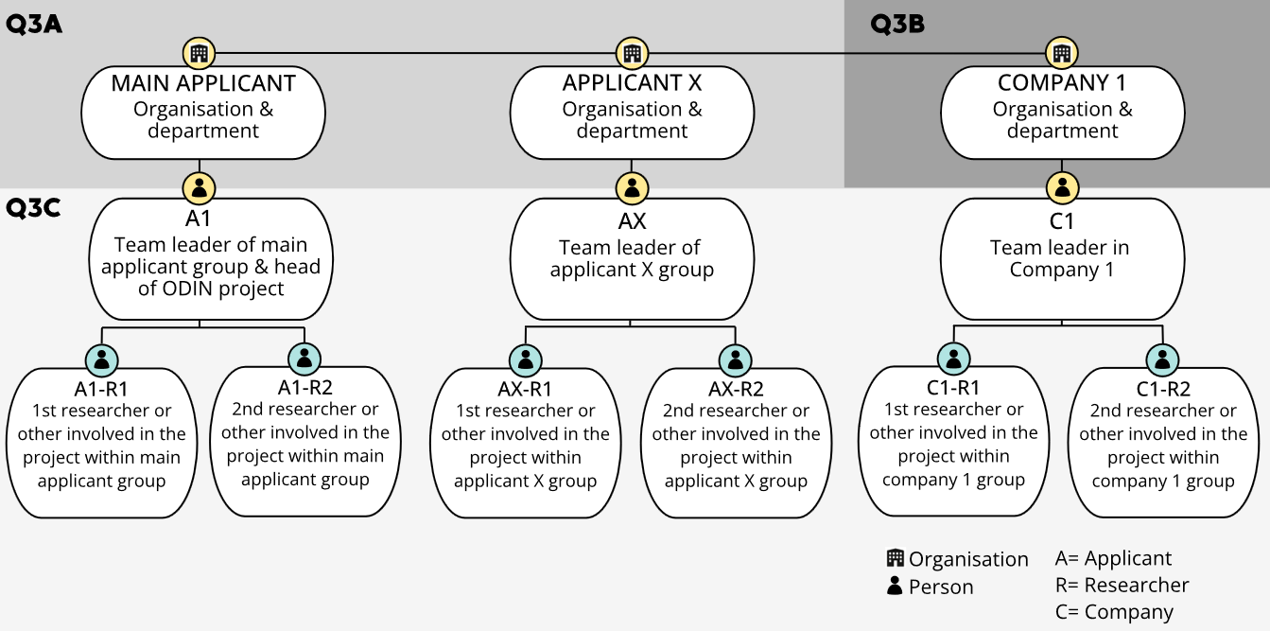
A2-R1: To be determined, lab assistant

LEADER OF EACH APPLICANT GROUP (only one leader per group. Academic group leaders must be (equivalent to) associate professor or above)
A1 (the person leading the ‘Main Applicant Organisation’ group): Name, title, organisation, country, email, phone
A2 (the person leading the ‘Applicant 2 Organisation’ group): Name, title, organisation, country, email, phone

LEADER OF EACH COMPANY GROUP
C1 (the person leading the ‘Company 1’ group): Name, title, organisation, country, email, phone

RESEARCHERS (OR OTHER STAFF) WORKING ON THE PROJECT
A1-R1 (the first researcher working under academic A1): Name, title, organisation, email, phone (if person is known)
A1-Rx (the Xth researcher working under academic A1): Name, title, organisation, email, phone (if person is known)
Ax-R1 (the first researcher working under group leader Ax): Name, title, organisation, email, phone (if person is known)
C1-R1 (the first researcher doing work for the project in relation to ‘Company 1’): Name, title, organisation, email, phone (if person is known)
CX-RY (the Y researcher doing work for the project in relation to ‘Company X’): Name, title, organisation, email, phone (if person is known)

4. EXECUTIVE SUMMARY
Character limit: 1500
Give a concise snapshot of the project, summarising the unmet need, GT2A project goal, key methods, expected open outputs, scientific/societal impact and innovation potential.

5. PREVIOUSLY FUNDED ODIN PROJECT
Character limit: 2000
- Describe the previously funded ODIN project, including its aims and expected outputs. Include the long-term goals/expectations for the original project in leading toward drug discovery and/or new diagnostics.
- Summarise the main results and open dissemination achieved so far, and which milestones are still pending.
- Explain whether the previously funded project is on track scientifically, financially, and operationally. If any objectives were not (or have not yet) been met, explain why, and whether this could interfere with the GT2A project’s aims.
- Explain how the new GT2A project idea emerged in relation to the previously funded project and describe the connection.

6. UNMET NEED, SCIENTIFIC APPROACH AND OPENNESS OF GT2A PROJECT
Character limit: 5500
Describe the new project, taking both the previously funded ODIN project and current state-of-the-art into account. Include the following:
- How the proposed work builds on and diverges from the original ODIN project to create new value. For example, how it changes the significance, usability, openness, or downstream innovation potential of the original project.
- The unmet medical or scientific need addressed by the new project within the ODIN scientific scope, and why current approaches are insufficient.
- The GT2A project’s aim, scientific rationale, and overall approach, including what is scientifically or technically novel or ambitious.
- The methodologies and/or technological solutions to be used, and how they differ from or improve upon existing approaches.
- The new knowledge generated by the end of the project, including the specific outputs (e.g., datasets, methods, models, or research tools).
- How outputs will be openly shared (e.g., repositories, preprints, open-access publications, software licenses, or data-sharing platforms).
- Why is Grant 2A funding necessary now, and why can the proposed work not be completed within the original ODIN project or other secured resources?

Detailed timelines, milestones, deliverables, decision points, and Gantt-linked work package descriptions should only be provided in Question 8A-B.
⚠️ Reviewers come from a range of scientific and industry backgrounds. Please ensure that your description is clear and accessible to non-specialists within the broader life science field.

7. VALUE CREATION & INNOVATION PATHWAYS
Character limit: 2000
Describe how the expected GT2A outputs could be utilised after the project to create value, compared with the previously funded ODIN project alone, for:
- Individual project participants and/or the project team as a whole.
- Company partners and other potential industry users.
- The wider research and innovation ecosystem beyond the team.
In addition, describe how the expected outputs will influence innovation pathways toward drug discovery or diagnostics, including technologies or services that enable their development. Consider both short-term and long-term innovation pathways.

8. FEASIBILITY & RISK MANAGEMENT

8A. Gantt chart
Upload your Gantt chart as 2 separate files – a readable PDF and an editable Excel version.
Name e.g. COOLPROJECT_GANTT.xlsx and COOLPROJECT_GANTT.pdf

8B. Implementation: Activities, Timeline, Deliverables and Milestones
Character limit: 2000
Explain the steps and timelines for carrying out your experimental plan, as well as resources (financial, technical, personnel) that are specifically required for the GT2A project. Include:
- Pre-project activities (before the official project starts), e.g., recruitment, obtaining consents & ethical approvals, project agreements, etc.
- Work Package descriptions (refer to Gantt labels).
  - Key activities in each work package (including feasibility and validation).
  - Key decision points (e.g., go/no-go criteria, branching paths).
  - Desired outcomes (deliverables/milestones).
  - End-Deliverables, including the primary outputs shared openly within 6 months of project end (e.g., paper submission, public database launched).
- Other relevant post-project activities.

8C. Risks and mitigation
Character limit: 2000
Highlight potential risks, how they may affect your project’s outcomes, and how you plan to resolve or work around them. Some examples:
- If the project depends on existing data, materials, software, know-how, or company-owned resources that could restrict open sharing or use of the new outputs.
- GDPR-related issues or other legal hurdles (e.g., software that cannot be fully open-sourced, clinical sample/ethics approvals, funder-imposed restrictions).
- Potential conflicts of interest (e.g., academic/company affiliations, or commitments to other funders that may limit openness or overlap in scope).
- Knowledge gaps in your core team.
- Reaching proof-of-concept or feasibility.
- Confidence that results will address the unmet need.
- Time constraints or workload issues due to concurrent research, teaching, or clinical responsibilities.

9. INTERDISCIPLINARITY AND INDUSTRY ENGAGEMENT

9A. Team Suitability and Contributions
Character limit: 2000
The “team” refers to all project participants, including academic/non-profit applicants, company partners, and associated researchers/TAP. Describe the team’s expertise, how the team members complement each other, their individual project roles, and expected contributions.

For each applicant and for-profit company partner, include:
- Whether they are continuing from the original ODIN project or newly added. Explain the connections.
- Why their expertise is needed for the GT2A project, and why they are motivated to join.
- What they will contribute, including the specific in-kind support from each company partner (linked to work packages where relevant).

9B. Company Letters of Support (LoS)
Upload Letters of Support from all actively participating companies using the LoS template. It is important that each LoS demonstrates the individual company’s engagement in the project.
- Each for-profit company partner must provide a LoS.
- Non-profit companies that are participating as co-applicants may optionally provide a LoS to elucidate their interest and any additional in-kind support.
Upload 1 PDF file for each company Letter of Support. Name, e.g., COOLPROJECT_NovoNordisk_LoS.pdf

  - 9C. LoS signatory
Provide the company, name, title (academic and professional), country, email address and phone number for the primary company executive who has signed each LoS.
Example Answer:
Novo Nordisk Signatory: Barbara Jensen, CEO, DK, baje@novo.com, +4511111111
Company 1 Signatory: Name, title, country, email, phone

9D. CVs
Upload PDF files containing the CVs for the leader of each applicant group, and for the primary researcher(s) representing each for-profit company partner who will actively contribute to the project. Do not include CVs for the company signatory executives (unless they are also active contributors). CVs should be relevant, concise, and focused on each person’s qualifications for their role in the project.
1 PDF file per person, maximum 2 pages each
Name, e.g., COOLPROJECT_JohnDoe_CV.pdf and COOLPROJECT_JaneDoe_CV.pdf

10. BUDGET

10A. Total budget – upload
Upload the budget as .xlsx. Instructions are provided in the budget template.

⚠️ For-profit company partners contribute in-kind and CANNOT receive a portion of the budget. They should not be included in your budget template.
Upload excel file e.g. COOLPROJECT_BUDGET.xlsx

10B. Signed budgets – upload as PDF
Each budget page must be approved and signed by the relevant applicant’s signatory authority, i.e., Head of Department (or similar).
- Upload all signed documents as a merged PDF [ACRONYM_signedbudget.pdf].
- Include the ‘total budget’ as the first page. Do not include the instructions page.
- Confirm that the document is readable as uploaded - this is the document the reviewers will assess
Upload one single PDF file containing all signature pages and overall budget page. E.g., [COOLPROJECT_signedbudget.pdf]
  - 10C. Name of each budget signatory
Provide the name, title, organisation, country, email address and phone number for the person who has signed each individual budget.

Example Answer:
Applicant 1 Signatory: Maria Jensen, Head of Dept., University of Copenhagen, DK, maje@ucph.com, +4533333333
Applicant 1 Signatory: Name, title, organisation, country, email, phone
Applicant 2 Signatory: Name, title, organisation, country, email, phone
  - 10D. Signed PhD statement(s) (if applicable)
Upload a signed PhD statement (use template) for each PhD student for whom salary is requested.
Upload PDF file(s) containing signed PhD statement(s). E.g., [COOLPROJECT_PhDstatement1.pdf, COOLPROJECT_PhDstatement2.pdf]
10E. Budget Justification
Character limit: 1000
Explain why the requested budget is proportionate to the additional work proposed, given the limited duration and top-up nature of the grant.
- Include major cost categories and why they are needed for the proposed work.
- Mention any co-financing that will be added to the budget from other sources.
- If any applicants (university/hospital/non-profits) are not receiving a portion of the budget, explain this discrepancy.
- If your budget includes subcontractors, briefly explain their role.
- If bench fees are requested, briefly explain which costs they cover, and differentiate these costs from the remaining budget (e.g., bench fees cover general lab. consumables, so these costs should not be included elsewhere in the budget).

11. Figures/Illustrations (optional)
Upload a single PDF file containing figures/illustrations necessary to explain the project. Provide a short legend for each (please limit text as much as possible).
Upload 1 single PDF file of max 2 pages. Name, e.g., COOLPROJECT_FIGS.pdf

12. References (optional)
Character limit: 1500
List up to 10 references that have been indicated in the application text. References should include Authors, Article Title, Journal Title, Year of Publication, and DOI.
We encourage references within the text to be numbers in brackets, e.g., [#].
  - 13. Keywords
Write up to five keywords to describe your project. Separate by commas.

QUESTIONS FROM THE EXTERNAL EVALUATORS
This section is used to gather feedback for evaluating the ODIN platform overall. Your responses will help us understand how applicants interact with the platform and where further support, or development is needed.
These responses are not shared with reviewers and have no impact on the evaluation of your application. However, they are invaluable for shaping the future of ODIN and Open Innovation in Science initiative, and we sincerely appreciate your time and input.
Partners
Why did you choose the new partners (if any), and why were some of the original team (if any) excluded?
Add your answer here…
Connection to original ODIN project
How was the original ODIN project used as a foundation for this proposal? Choose all that apply:
- Reuse or extension of data/insights from original project.
- Follow-up research question that emerged during original project.
- Involvement of original project participants.
- Expansion of original methodology/tools/platform.
- Other.
If you chose ‘other’ above, please elaborate:
Add your answer here…
Additional Feedback
Is there any additional feedback or information you would like to share with the ODIN Secretariat or external evaluators? This could include suggestions for improving the process, reflections on the platform experience, or anything else you'd like us to consider.
Add your answer here…

APPLICATION CHECKLIST
Please familiarise yourself with the call documents well ahead of the submission deadline, as the application process includes steps that require involvement from partners and/or support functions at all project partners’ local universities. Templates are provided, please check below to see if their use is mandatory.
Documents can be downloaded on WorldLabs.
ADMINISTRATIVE STEPS
 | Approval from the project team from the previously funded ODIN project  Discuss and get approval for the plan for the 2A project from the project team from the previously funded ODIN project.
 | Post idea on WorldLabs  Ideas uploaded by 23 August can be supported in matchmaking.  Final deadline for posting ideas on WorldLabs: 13 September 2026. | Template  provided
Finalise project team
Must include at least the eligible main applicant and one for-profit company partner.
Contact local development advisor
Contact the main applicant’s local development advisor to have them assess that the project appears to be precompetitive, that it does not appear to violate any existing Intellectual Property Rights (IPR), and that any knowledge created within the project can be shared openly.
Ensure legal compliance
Consider whether the project requires legal, GDPR, ethical, regulatory or contractual approvals, or agreements, and if timelines could be affected. Contact legal or compliance specialist at the main applicant's organisation if relevant.

APPLICATION
 | Application  The application must be submitted via WorldLabs by 15:00 on 24 September 2026. A template is available for offline use, if preferred. | Template  provided
Curriculum Vitae (CV)
From the leader of each applicant group and main researcher/ employee of each company. Max. 2 page per person. Upload as PDF.
 | Letter of support  From each involved for-profit company partner confirming their interest in the ODIN project application, including a description of their specific in-kind contributions. Upload as PDF. | Template use  mandatory
 | Gantt chart  With work packages and activities for all participants, including milestones, recruitment, ethics approval and data sharing timelines. Upload as Excel and PDF. | Template use  mandatory
 | Signed Budget  Must be approved and signed by all heads of department, or equivalent, for each applicant organisation, to ensure that the individual budgets comply with local budgeting rules.  Upload as Excel and PDF. | Template use  mandatory
 | PhD student documentation (if relevant)  Please see Section A2.1 in the 2026 ODIN Grant Type 2A guidelines. | Template use  mandatory
Figures
Recommended. 2 pages saved in a single PDF.

