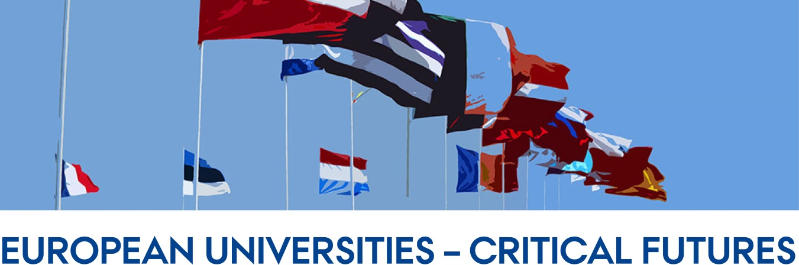

Inaugural Conference and integrated PhD Course
6-8 May 2019
Danish School of Education (DPU), Tuborgvej 164, 2400 Copenhagen NV, Denmark

Programme

Abstracts of lectures, descriptions of the sessions, and reading materials are found in the document ‘Preparations for the Conference/PhD Course’

Pre-arrival – by 26 April
Please send the following information to Iulia Iordache-Bryant (iulia.iordache@edu.au.dk) by 26 April 2019:
- A short introduction to yourself (½ page A4) with photo – focusing on aspects that relate to the orienting question for the search conference:
How can we rethink and restructure the roles that European universities can/should play in countering increasing socio-economic inequality and consolidating European research and education efforts in a dynamic global context?
- A brief outline of your current research project – maximum 1 side of A4. (each participant is asked to do this, as a basis for matching PhD students with suitable senior researchers as discussants of their projects)

Day 1: 6 May 2019 Room D170
Search Conference - Collaborative thinking on universities’ critical futures
Arrival
12.00-12.30 Sandwich lunch

12.30-13.00 Introductions

13.00-14.00 Search Conference Phase 1: Shared history - creation

14.00-14.45 Phase 2: Shared history - explanation

14.45-15.00 Coffee available

14.45-15.30 Phase 3: Probable future

15.30-16.15 Phase 4: Ideal future

16.15-16.30 Instructions for Day 2 – Evening homework: “Keep-Drop-Create”

16.30-17.30 Refreshments on the terrace

17.30-19.00 Dinner

19.00- 20.30 Room A200
Lecture and discussion: Changing values of European universities
Dr Sijbolt Noorda, President of the Magna Charta Observatory, Bologna
Former president Universiteit van Amsterdam and VSNU (Dutch universities association)

Day 2: 7 May – Room A200
Collaborative thinking on universities’ critical futures

Search conference - Continued
9.00-10.00. Phase 5: “Keep-Drop-Create”

10.00-10.30 Phase 6: Thematise/prioritising topics emerging from “Keep-Drop-Create” and form groups.

10.30-10.45 Coffee and goodies

10.45- 11.45 Phase 7: Group work on Force-Field analysis on identified topics

11.45-12.30 Plenary

12.30-13.15 Lunch

13.15-14.15 Phase 8: Group work on Action planning

14.15-15.15 Plenary - Report back – Search Conference ends.

15.15-15.30 Break

Research Themes, Part 1
15.30- 16.15 Theme 1 The role of universities in European social and political integration (social mobility, refuges, democracy, etc) Tim Seidenschnur, Jens Jungblut, Sue Wright

16.15-17.00 Theme 1 – next steps Tim Seidenschnur, Jens Jungblut, Sue Wright

18.30-20.00 Dinner

**************

Day 3: 8 May 2019 – Room A200

9.00-10.00 Lecture: Methods of future making (provisional title)
Marijk van der Wende

10.00-10.15 Break

10.15-11.30 PhD projects on Themes 1, 2 and 3
(Discussion of PhD students’ projects in small groups with senior academics from each theme)

11.30-12.15 Lunch

Research Themes, Part 2
12.15-13.00 Theme 2 The roles of universities in integration of European research and higher education (global knowledge economy, ERA, EHEA, etc) Amelia Veiga, Krystian Szadkowski

13.00-13.45 Theme 2 – next steps Amelia Veiga, Krystian Szadkowski, Sue Wright

13.45-14.00 Break

14.00-14.45 Theme 3 European universities in a shifting global context (China’s rise and other countries’ competing global strategies) Marijk van der Wende, Jie Gao (Freya)

14.45-15.30 Theme 3 – next steps Marijk van der Wende, Jie Gao (Freya), Sue Wright

15.30 -16.30 Plenary –Participatory process and planning ahead Sue Wright

Conference Ends

